**WORK REPORT**

***Zaika Rasoi Website Assignment 4 - Report***

I made a 3-page restaurant website using HTML, CSS, JavaScript. It works on phones, tablets, and computers.

**Pages:**

**Home Page -** More graphical that shows big food pictures with little text. Has icons for delivery, spice and takeout.

**Menu Page -** A detailed products page that Lists all food with photos, descriptions, and prices in neat cards.

**About Page -** Tells the restaurant's story with one main photo of its background culture.

All page’s link to each other through a navigation menu.

**1. Home Page (ZaikaRasoi.html):** Features a large hero image of Indian food (graphical focus), contains minimal text with just a welcome message. Shows key features through icons for delivery, takeout, spice.

**2. Menu Page (Menu.html):** Displays all menu items in a responsive grid, Clear name, Detailed description has price display.

**3. About Page (About.html):** Tells the restaurant's story: Responsive Design Implementation I followed mobile-first principles designing for mobile screens first, then adding enhancements for larger screens. Added hamburger menu for mobile, Flexible grids that adapt to screen size, everything resizes properly, easy to read on any device

**Technical Implementation**

HTML for structure and I made proper linking between all pages, CSS for colors/layout and Mobile-first media queries., JavaScript: I used basic mobile menu toggle

Design for visual display: I choose maroon and gold colors to relate to the culture, Big, clear photos and Simple fonts easy to read.

**TESTING:**

I tested the website on  
1. **MacBook pro: Google Chrome Version 134.0.6998.89 (Official Build) (arm64).**

Screenshots of Page 1 Home page (ZaikaRasoi.html) , Google Chrome Version 134.0.6998.89:  
  
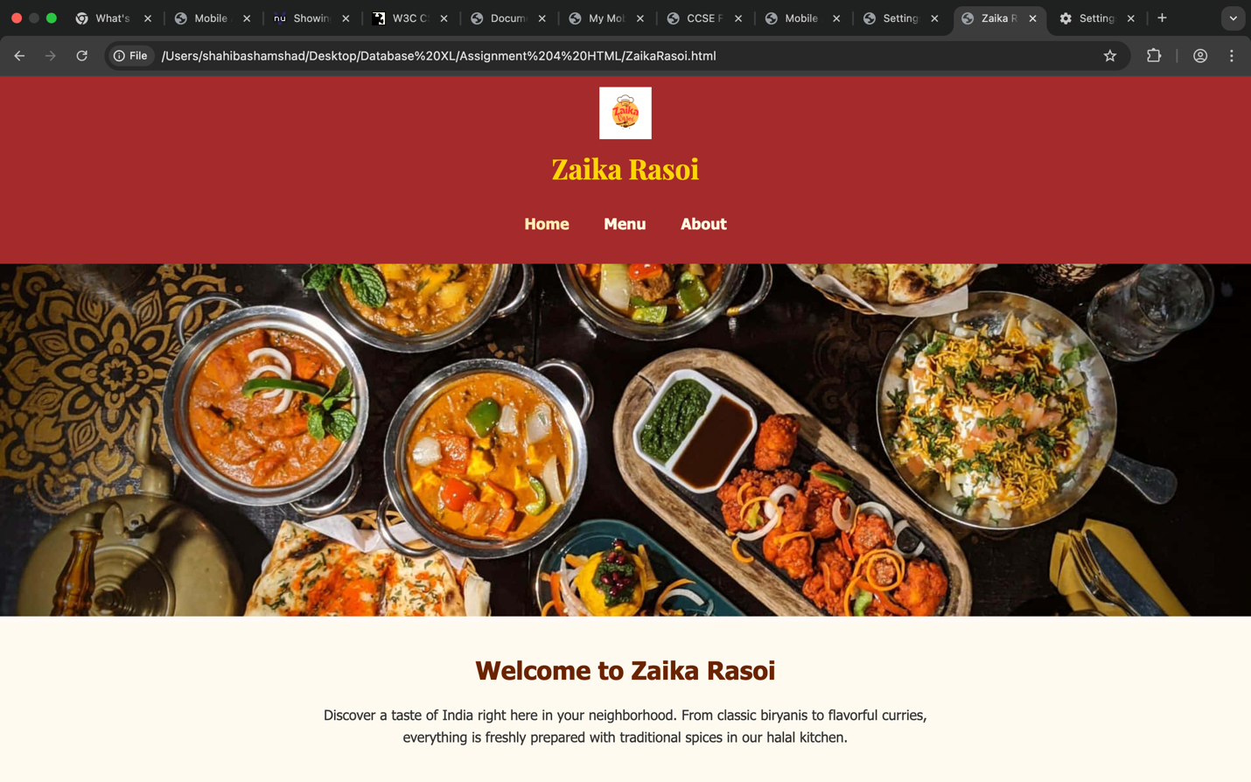  
  
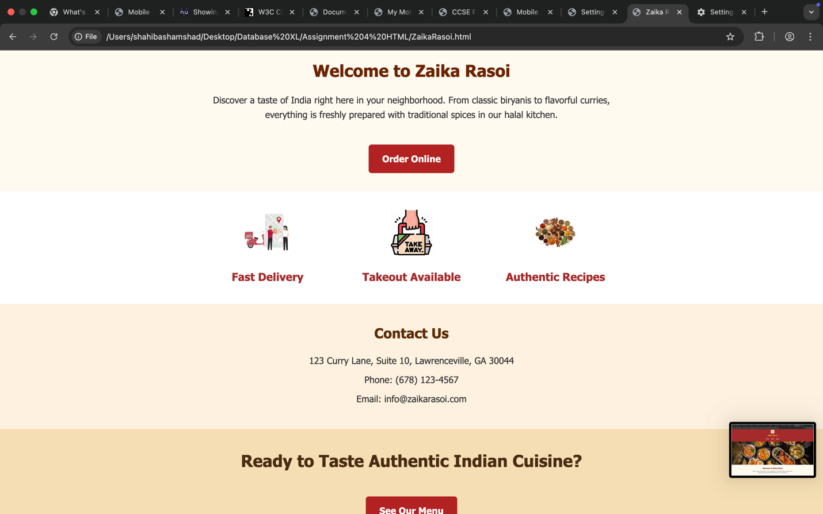

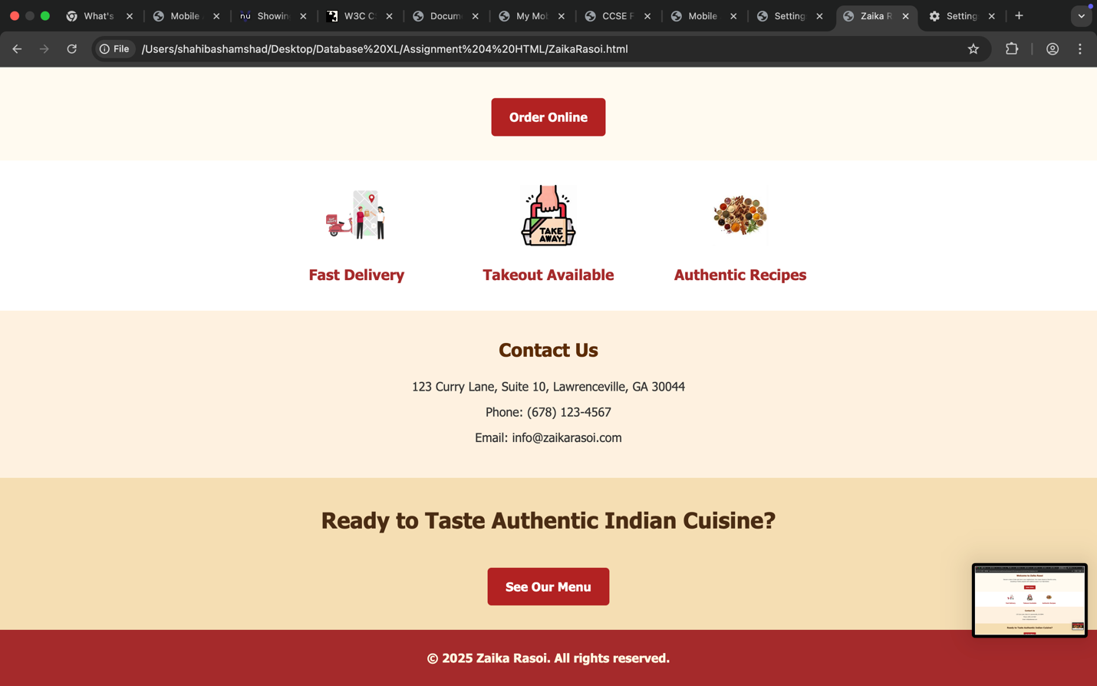

**Screenshot of Page 2(Menu.html) Google Chrome Version 134.0.6998.89:**

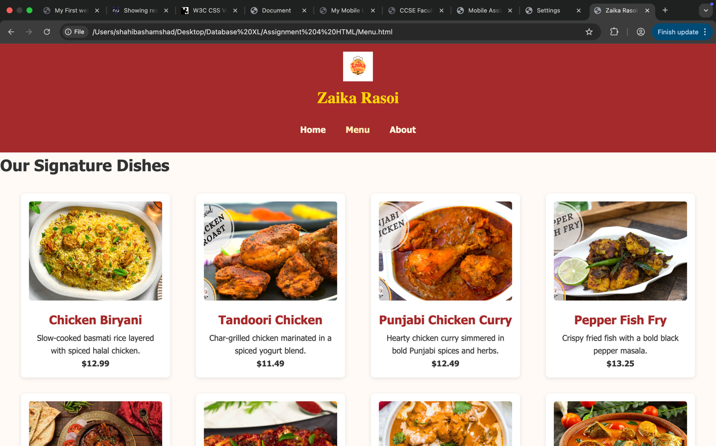

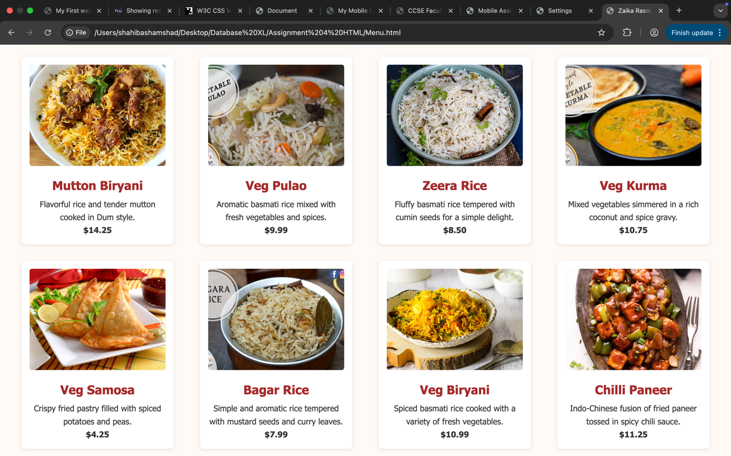

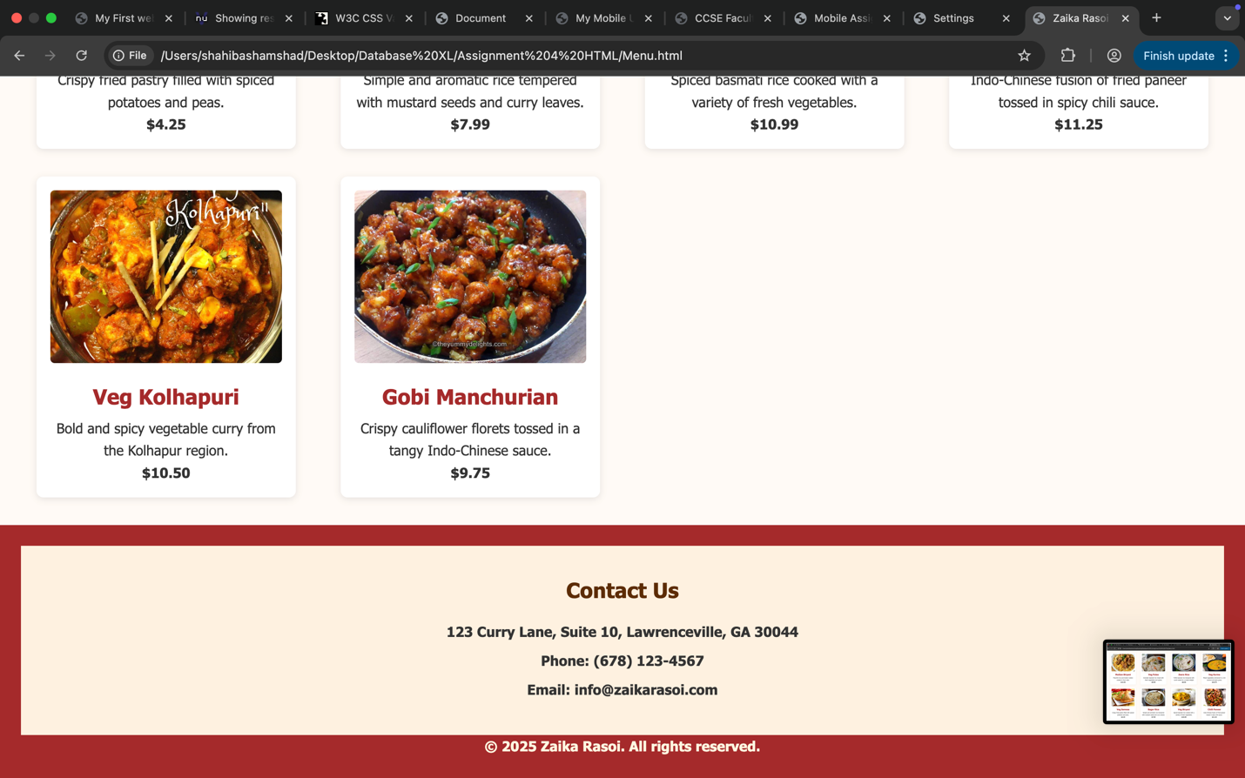

**Page 3 (About.html) Google Chrome Version 134.0.6998.89:**

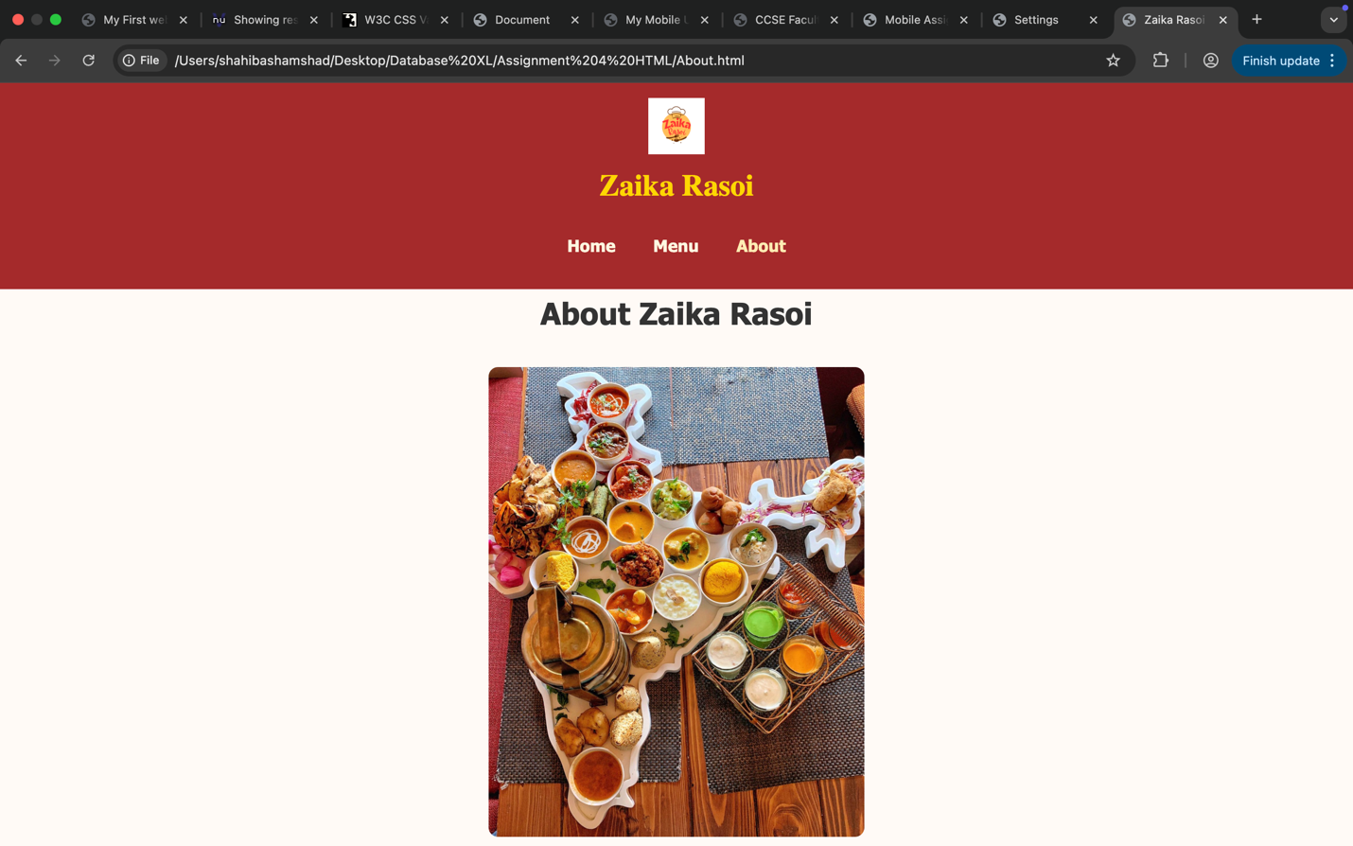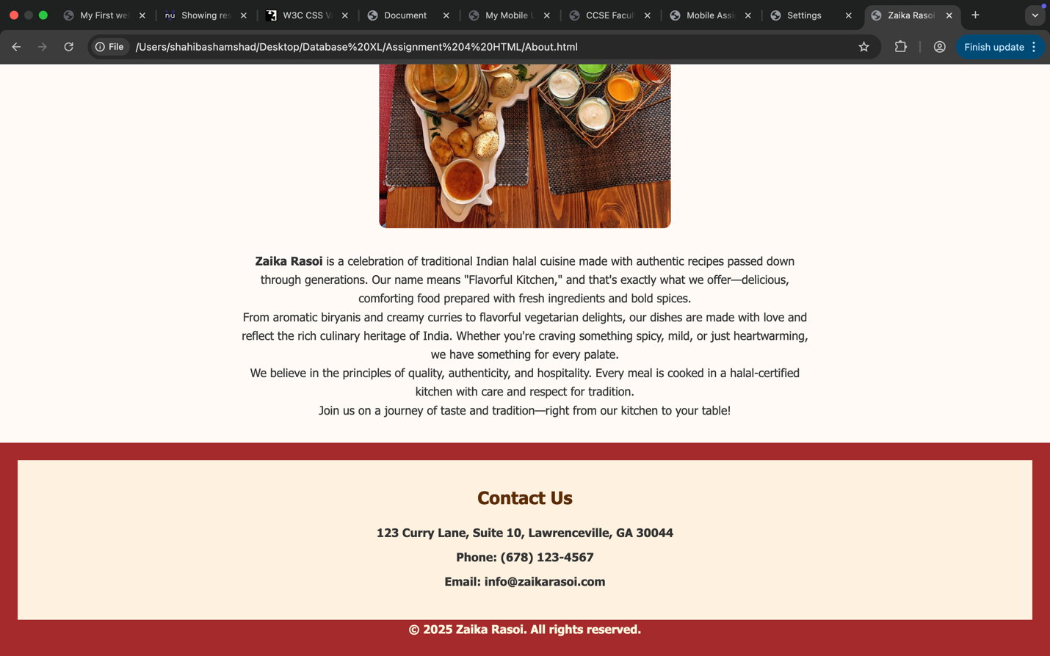

**2. Testing environment – iPhone 14 pro max (430 x932):**

Page 1 in Portrait and Landscape iPhone 14 pro max:

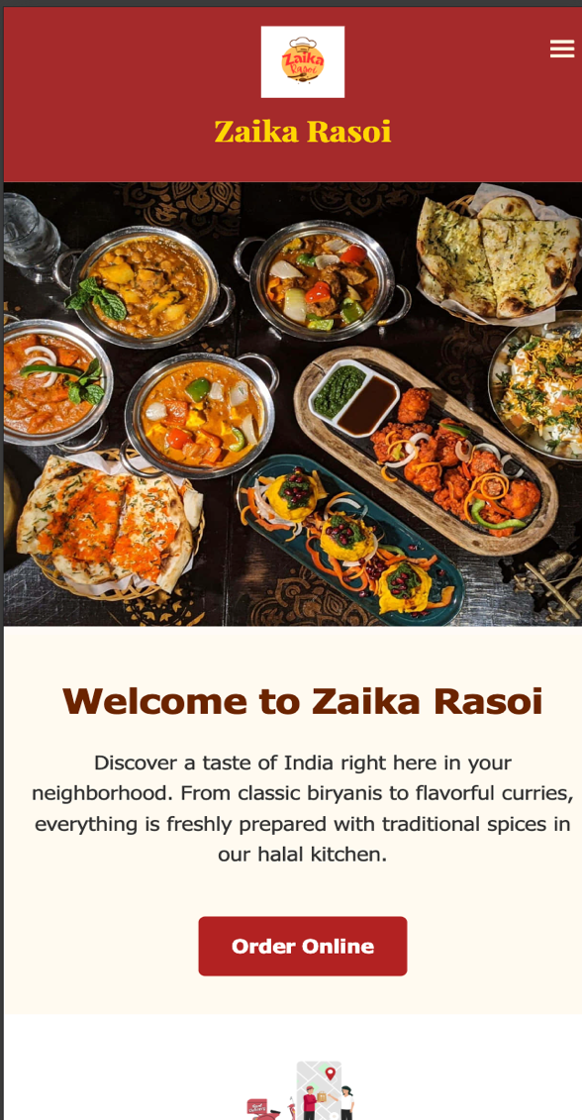 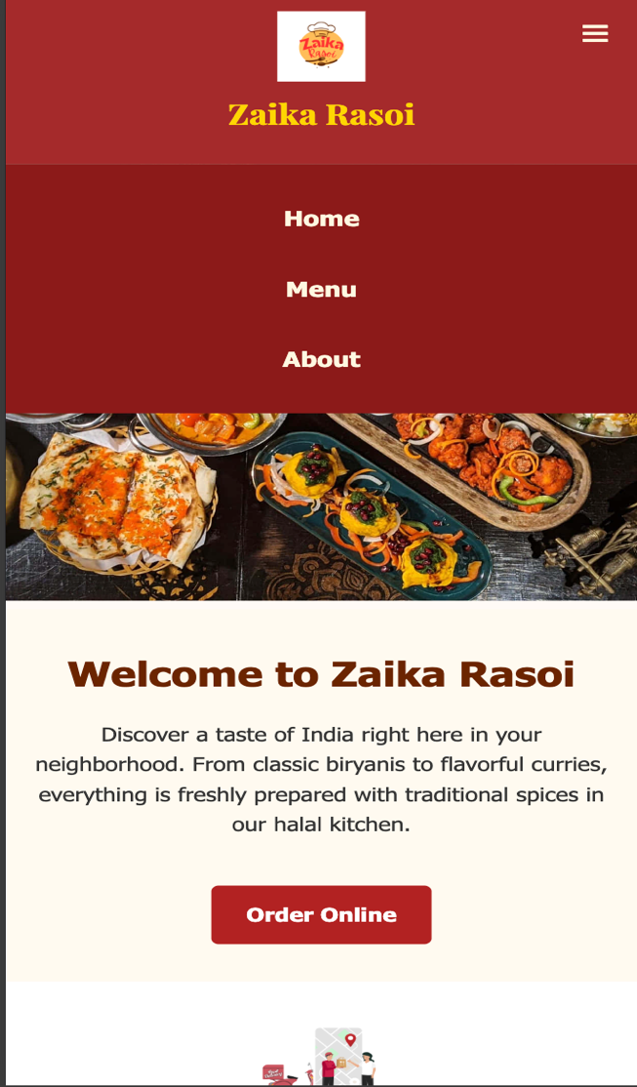

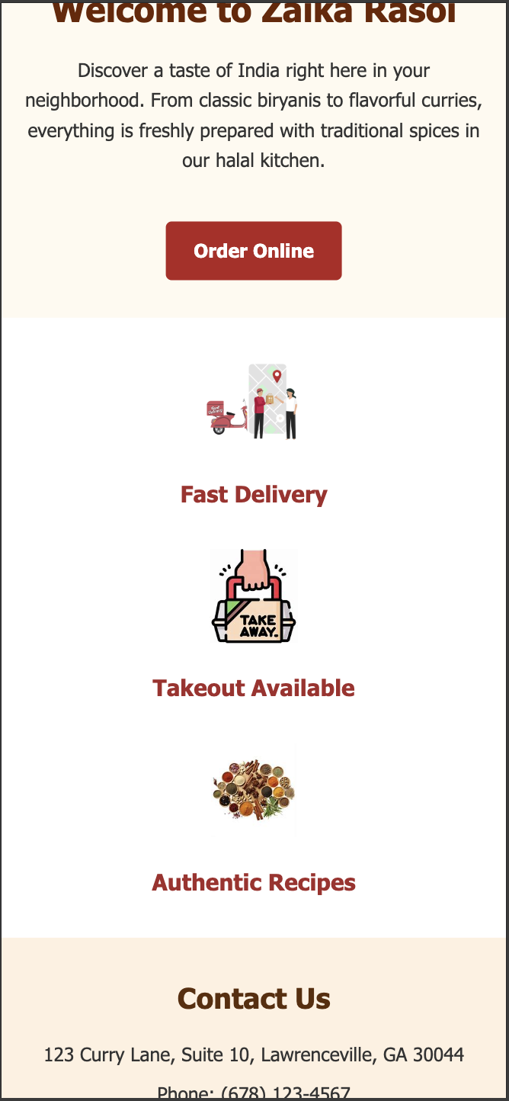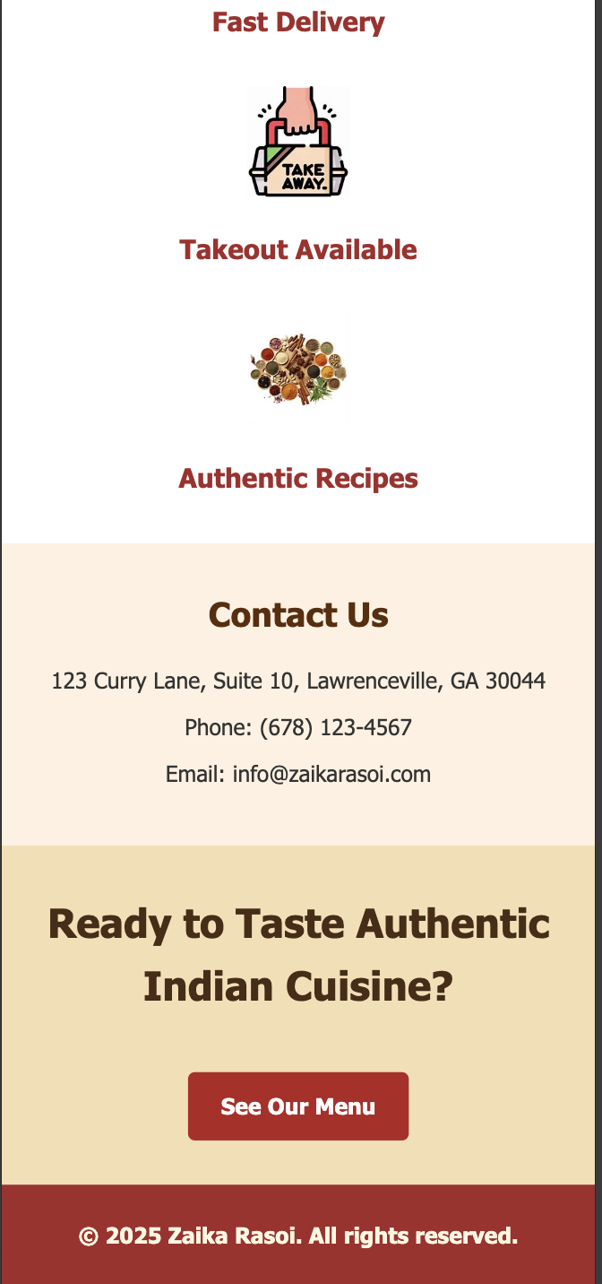

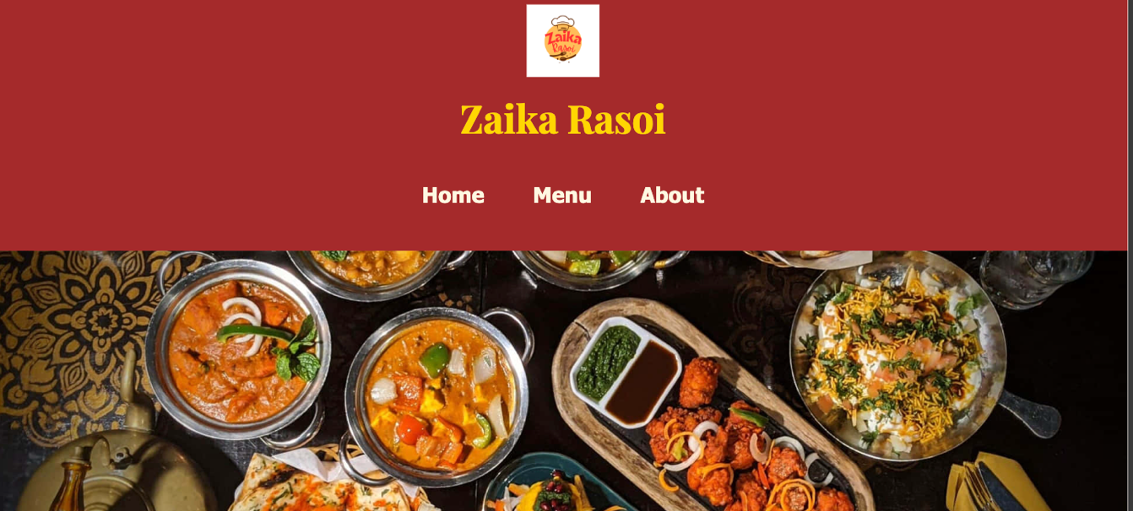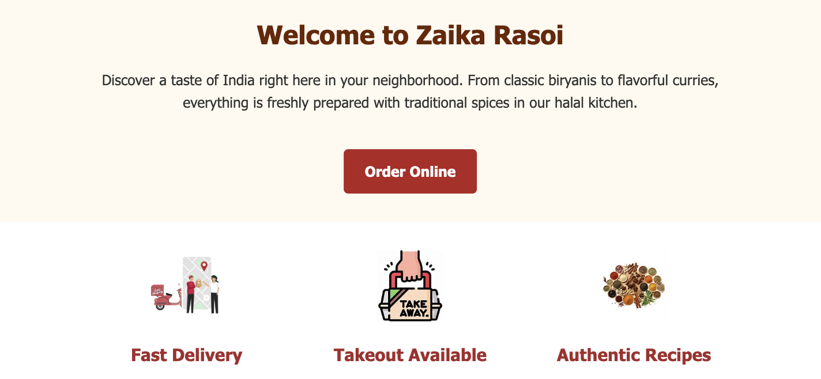

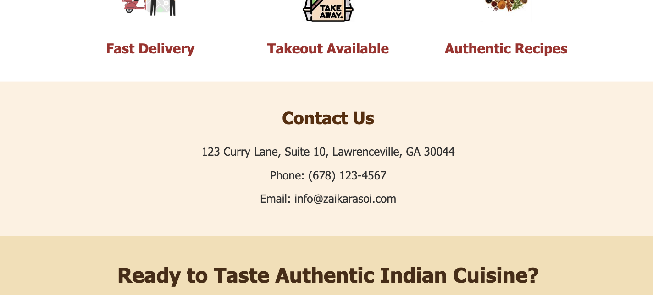

**Page 2 (menu.html) portrait and landscape iPhone 14 pro max:**

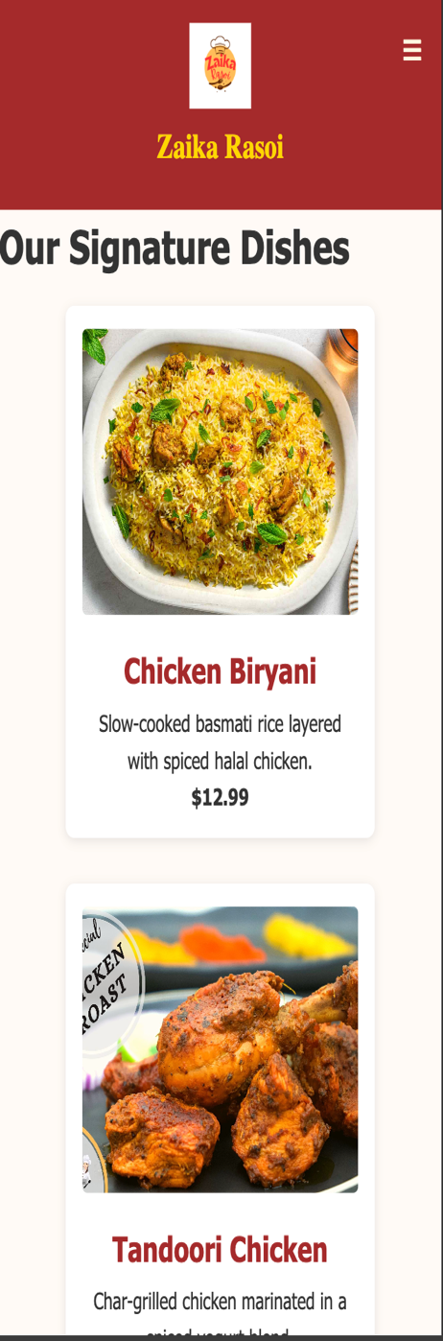 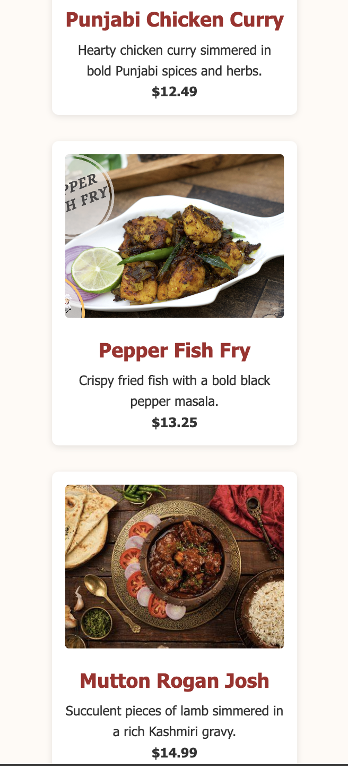 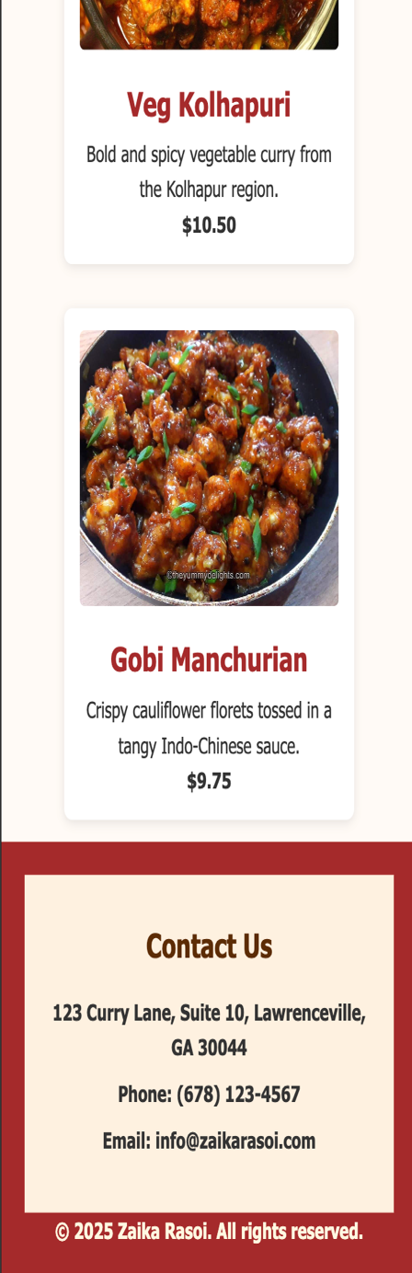

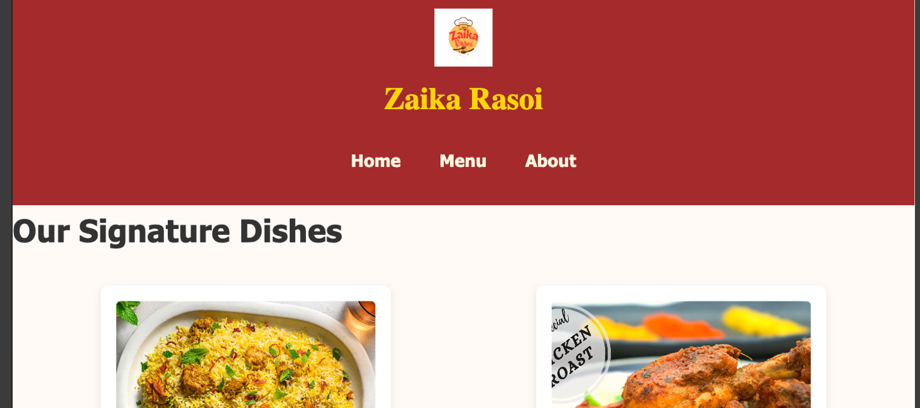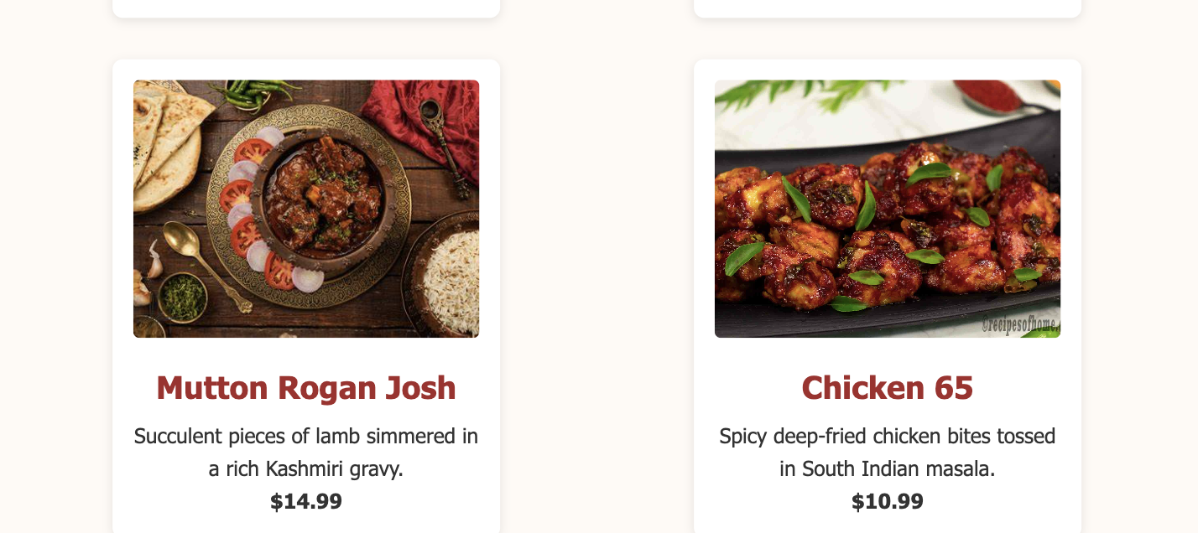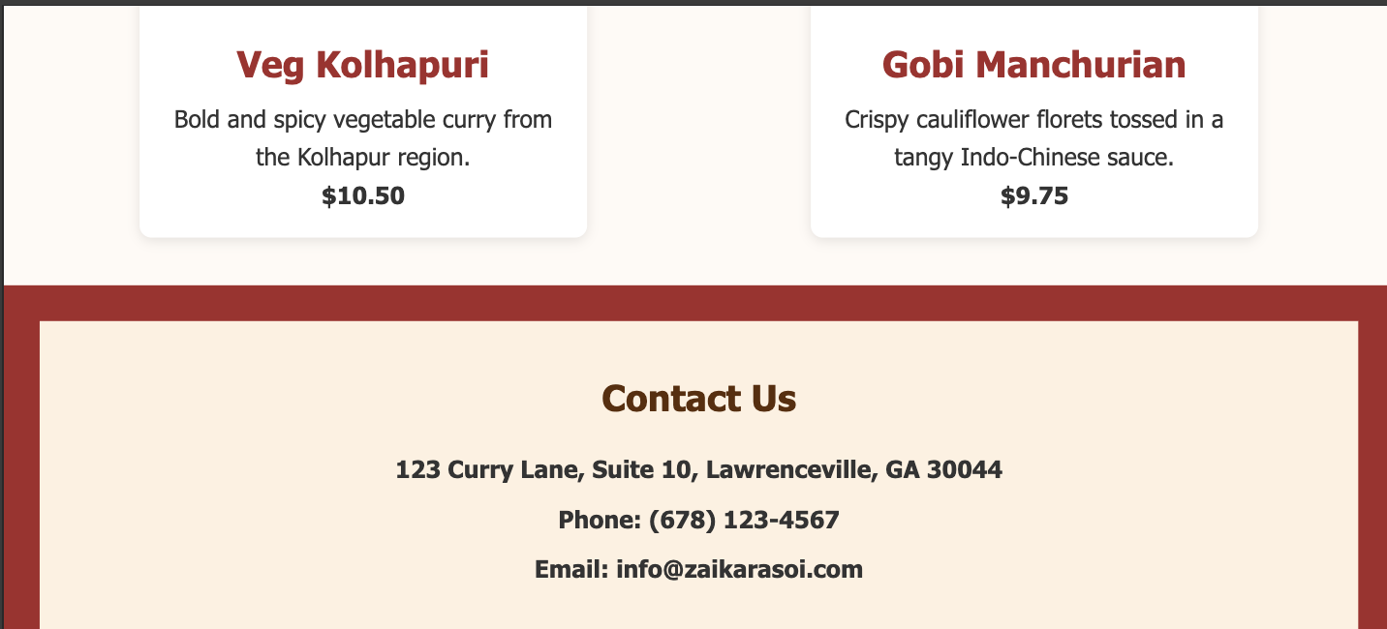

**Page 3 (iPhone 14 pro About.html) iPhone 14 pro max:**

